Binary search

#include <stdio.h>

int main() {

int arr[5], n, mid, i;

printf("Enter 5 elements sorted:\n");

for (i = 0; i < 5; i++) {

scanf("%d", &arr[i]);

}

printf("Enter element to be searched:\n");

scanf("%d", &n);

int start = 0;

int end = 4;

while (start<=end) {

mid = (start+end)/2;

if (arr[mid] == n) {

printf("The number is found at index %d", mid);

return 0;

}else if (n>arr[mid]) {

start = mid+1;

}else {

end = mid-1;

}

}

printf("The number is not found");

return 0;

}

Binary search output:

1. No. found

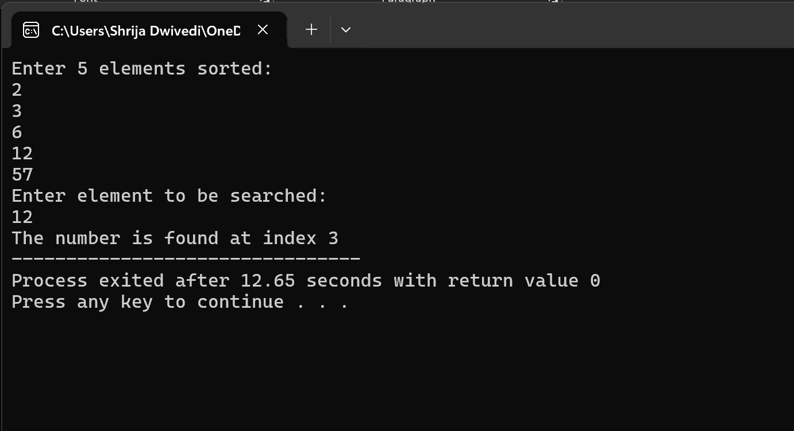

1. No. not found

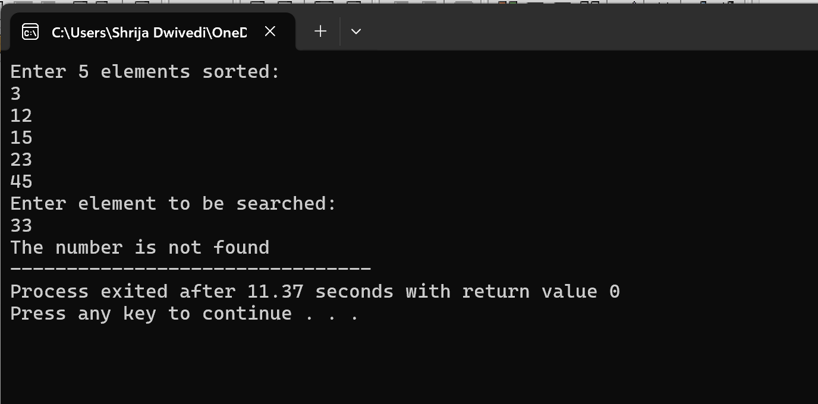

Linear search

#include<stdio.h>

int main(){

int arr[5],n,found=0,i;

printf("Enter 5 elements \n",n);

for(i=0;i<5;i++){

scanf("%d",&arr[i]);

}

printf("Enter element to be searched \n");

scanf("%d",&n);

for (i=0;i<5;i++){

if (arr[i]==n){

printf("The number is found at index %d",i);

found=1;

}

}

if(found==0)

printf("The number is not found");

return 0;

}

Linear search output:

1. No. found:

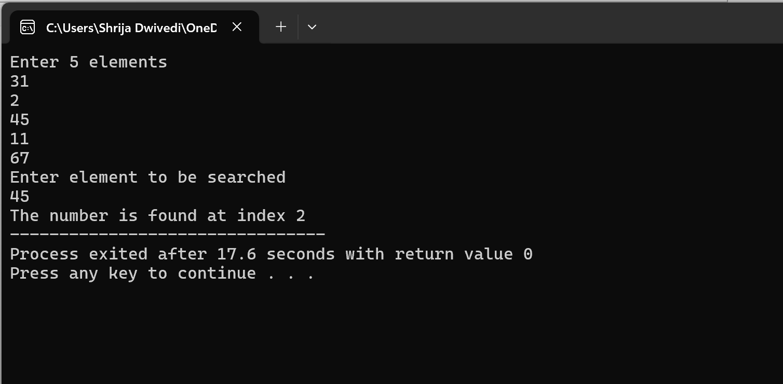

1. No. not found:

